Software Requirement Specifications
ONLINE JOB PORTAL SYSTEM



Submitted by
Abdul Saboor (F22BINFT1M01258)

Submitted to
Mr. Muzamil ur Rehman

Department of Information Technology
Faculty of Computing
The Islamia University of Bahawalpur

Meeting Details
Sr No | Details | Date | Supervisor Signature

Summary

This document provides the complete Software Requirements Specification (SRS) for the Online Job Portal System, a dynamic web-based platform developed to digitalize and simplify the hiring process for both job seekers and employers. The system provides a structured and efficient environment where candidates can easily explore job opportunities and employers can effectively manage recruitment activities through separate, role-based functionalities.
The system supports two main user roles: Job Seekers and Employers. Job seekers can register, log in, update their profiles, upload resumes, explore available job listings, filter jobs based on skills or categories, and apply instantly through a simple and intuitive interface. Employers, on the other hand, have access to a dedicated dashboard where they can create company profiles, post new job vacancies, update or remove old listings, review applications, download resumes, and shortlist or reject candidates. The dashboards for both roles are designed to display personalized information, such as applied jobs for seekers and total applicants for employers.
The system maintains all information in a MySQL database, ensuring structured data storage for users, job posts, applications, notifications, and company details. It utilizes HTML, CSS, JavaScript, PHP, and MySQL, offering a responsive design, form validations, secure login, and efficient server-side processing. Features like password hashing, SQL query protection, input validation, and separate login handling for each role help ensure the system’s security and reliability.
Additionally, the system reduces manual efforts by providing automated matching between job posts and applicant skills, quicker communication, and centralized management of all recruitment activities. The SRS covers the system’s background, overall description, functional and non-functional requirements, constraints, and assumptions to ensure that every stakeholder has a clear understanding of project scope and behavior.
Overall, this document establishes a strong foundation for development, testing, and future enhancement of the Online Job Portal System by clearly defining what the system must achieve and how it should perform to meet user needs

Table of Contents

Summary 3
1.1 Purpose 6
1.2 Scope 7
1.1 Definitions, Acronyms, and Abbreviations. 7
1.2 Product Perspective 8
1.2.1 System Interfaces 8
1.2.2 Interfaces 8
1.2.3 Hardware Interfaces 9
1.2.4 Software Interfaces 9
1.2.5 Communications Interfaces 9
1.2.6 Memory Constraints 9
1.2.7 Operations 9
1.3 Product Functions 9
Job Provider / Employer 10
Job Seeker 10
Manager / Admin 10
1.4 User Characteristics 10
1.5 Constraints 11
1.6 Assumptions and Dependencies 11
1.7 Apportioning of Requirements 11
2. Software Required Specifications 12
2.1 Specific Requirements 12
2.1 External Interface Requirements 13
2.1.1 User Interfaces 13
2.1.2 Hardware Interfaces 13
2.1.3 Software Interfaces 13
2.2 Functional Requirements 14
2.2 Performance Requirements 20
2.3 Logical Database Requirements 20
2.4 Design Constraints 20
2.4.1 Standards Compliance 20
2.5 Organizing Specific Requirements 21
2.5.1 System Mode 21
2.5.2 User Class 21
2.5.3 Objects 21
2.5.4 Features 21
2.5.5 Stimulus & Response 21
3 System Design and Architecture 22
3.1 Introduction to Use case Diagram 22
3.1 Job Provider use case diagram 23
3.2 Job seeker use case Diagram 24
3.3 Job Application Management Use Case Diagram 25
3.4 Job Application Management Use Case Diagram 26
3.5 Complete Use case Diagram of OJP 27
3.5.1 Data entities and their relationships 27
Entities and Attributes 27
Relationships 28
Representation in ER Diagram 28
3.6 Non-Functional Requirements 28
3.4.1 Performance 28
3.4.2 Reliability 28
3.4.3 Availability 29
3.4.4 Security 29
3.4.5 Maintainability 29
3.4.6 Portability 29
3.5 Inverse Requirements (Constraints / Restrictions) 30
3.6 Logical Database Requirements 30
3.7 Design Constraints 31
4 Analysis Model 31
4.1 Analysis Model Discussion 32
4.2 Sequence Diagram 32
4.2.1 Add-User 33
4.2.2 Update- User 34
4.2.4 Delete- User 35
4.2.5 Complete OJB sequence diagram 36
4.3 DFD Diagram 37
DFD Levels in OJP 37
4.3 Detailed DFD 39
References 40

Chapter 1
Introduction

This project is developing an online search Portal for the Placement Details for job seekers. The system is an online application that can be accessed throughout the organization and outside as well with proper login provided. This system can be used as an Online Job Portal for job seekers. Job Seekers logging should be able to upload their information in the form of a CV. Visitors/Company representatives logging in may also access/search any information put up by Job aspirants. Currently we working on a manual system where data is stored in register and with the born of internet most of the peoples have started searching jobs over an internet looking such requirements peoples are making much use of internet rather than the print media for finding employees or posting jobs, previously newspaper plays an important role for searching out an experienced employees or jobs. Now employers and employees are searching online job portals for finding jobs respectively. This job portal come prove to be very helpful since it allows user of different profile to upload their CVs, search jobs on the basis of their qualification. Every user can access through user id and apply for multiple jobs at a time. The developed portal management is a web based which require employee’s registration and profile. When the recruiter logs into the system he will be able to view the profile separately along with uploading the information of new created jobs. Thus, job miller is common platform where recruiter and jobs seekers come under the same roof.

Purpose
This section describes the requirements and specifications of Online Job Portal Web Application. This document details all features upon which Online Job Portal Web Application have currently decided with reference to the manner and importance of their implementation. Online Job Portal Web Application is designed to produce the management of a Online Job to manage their system in a best way. In Online Job Portal the management of the Job Portal will be able to store update and view the record of the Jobs. This system will provide a best facility to the management to run their system in a best way. Online Job firms currently use a manual system for the management and maintenance of critical information. The current system requires numerous paper forms, with data stores spread throughout the Online Job management infrastructure. Often information (on forms) is incomplete or does not follow management standards. Records are often lost in transit during computation requiring a comprehensive auditing process to ensure that no vital information is lost. Multiple copies of the same information exist in the Online Job firm data and may lead to inconsistencies in data in various data stores.

Scope
In Online Job Portal Web Application we provide facility to the management of the Online Job system to add update and review the details of their customers and employees as well. By using this application the management will be able to add remove and update the record of their customers.

Definitions, Acronyms, and Abbreviations.
Provide the definitions of all terms, acronyms, and abbreviations required to properly interpret the SRS. This information may be provided by reference to one or more appendices in the SRS or by reference to documents. This information may be provided by reference to an Appendix.

Term | Definition
Problem Statement | A concise description of the issue addressed by the Online Job Portal System. It identifies the gap between the current recruitment process (manual or inefficient) and the desired state (automated and streamlined process). It helps the project team stay focused and verify that goals are achieved.
Entry | A single record or item collected, such as a user registration, job posting, or job application, within the system.
Job Provider (Employer) | A person or organization that posts job vacancies, manages job listings, and reviews applications on the Online Job Portal.
User | Any individual interacting with the system, including Job Seekers and Employers. Examples: a Job Seeker applying for a job or an Employer managing applications.
Research Objective | A clear, concise statement guiding the investigation or development of the system. It focuses on measuring variables such as user satisfaction, system efficiency, and functionality.
GUI (Graphical User Interface) | The visual interface through which users interact with the system, including forms, dashboards, buttons, and menus.
SRS (Software Requirements Specification) | A detailed document describing the functional and non-functional requirements of the system, defining what the system must achieve.
SDD (Software Design Description) | A document outlining the system architecture, modules, data flow, class diagrams, and design decisions for implementing the system.
SQL (Structured Query Language) | A programming language used for managing and querying the system’s MySQL database.
PHP | A backend programming language used to develop the server-side logic of the Online Job Portal System.

The first section is named as Overall Description and gives an overview of the functionality of the product. It describes the informal requirements and is used to establish a context for the technical requirements specification in the next section. The second section, Specific Requirements, of this document is written primarily for the developers and describes in technical terms the details of the functionality of the product. Both sections of the document describe the same software product in its entirety, but are intend for different audiences and thus use different language. It describes functional as well as non-functional requirements of this web application. Different use cases, block diagram and class diagram have been drawn for further explaining of system working.

Product Perspective
The Online Job Portal (OJP) System is a web-based platform designed to connect job seekers with employers efficiently and improve the overall recruitment process. The system provides a job catalog and detailed information to members, helping them decide on suitable jobs to apply for. The admin ensures that the job catalog is always updated, so both job seekers and agencies have access to the latest information. The main users of the system are: Job Seekers, Job Providers (Employers), and Admin/Manager.
In the OJP web application, Job Providers (Employers) and Job Seekers must use their login ID and password to access the system and perform their respective operations. Job Providers can manage job posts and review applications, while Admin/Manager oversees the system and manages user accounts.

1.2.1 System Interfaces
This section highlights the interfaces used in the system. As a web application, the system stores data in a SQL database and retrieves it as needed. A secure login interface for Job Providers, Job Seekers, and Admin is provided.

1.2.2 Interfaces
The system uses a Graphical User Interface (GUI). GUI ensures that all operations are visual and user-friendly, making it easier for users to navigate and understand the system effectively.

1.2.3 Hardware Interfaces
The system has no specific hardware interface requirements. However, it is recommended to use a computer with a good configuration for smooth operation.

1.2.4 Software Interfaces
The system uses SQL Database for data storage and PHP for backend connectivity. No additional software is required beyond standard web development tools and database systems.

1.2.5 Communications Interfaces
No external communication interfaces are required. All operations occur within the web application, communicating securely with the SQL database.

1.2.6 Memory Constraints
It is recommended that the system runs on a computer with at least 512 MB of RAM. No specific requirement exists for secondary storage beyond what is needed to store user and job data.

1.2.7 Operations
- Job Provider / Employer can:
  - Create and manage job posts.
  - View applications submitted by job seekers.
  - Shortlist or reject applicants.
- Job Seeker can:
  - Register, create a profile, upload resume.
  - Search for jobs and apply.
  - View status of submitted applications.
- Manager / Admin can:
  - Add, update, or remove Job Provider and Job Seeker accounts.
  - Approve or reject job posts.
  - Monitor system activities and maintain data integrity.
- All users interact with the system through secure login and personalized dashboards.

Product Functions
The OJP web application provides different functions depending on the type of user. The main product functions are described below:

Job Provider / Employer
- Job Provider logs in using a secure login panel.
- Job Provider can create, update, or delete job posts.
- Job Provider can view applications submitted by Job Seekers for their job posts.
- Job Provider can shortlist or reject applicants.
- Job Provider can view job post status and history.

Job Seeker
- Job Seeker can register and log in securely.
- Job Seeker can create and update their profile.
- Job Seeker can upload their resume.
- Job Seeker can search for jobs based on criteria (location, category, etc.).
- Job Seeker can apply to jobs and track the status of their applications.

Manager / Admin
- Manager/Admin logs in using a secure login panel.
- Manager/Admin can add, update, or remove Job Seeker accounts.
- Manager/Admin can add, update, or remove Job Provider accounts.
- Manager/Admin can review all job posts submitted by employers.
- Manager/Admin can approve, reject, or delete job posts if required.
- Manager/Admin can monitor overall system activity and maintain data accuracy.
- Manager/Admin can manage notifications or announcements within the system.

User Characteristics
The users of the Online Job Portal (OJP) System include Job Seekers, Job Providers (Employers), and Manager/Admin. The system is designed for users with the following characteristics:
- Basic Computer or Smartphone Knowledge:
  - Users should be able to operate a computer, laptop, or smartphone.
  - Users should be able to navigate websites, use buttons, links, and forms.
- Login Credentials:
  - All users must be able to securely log in using their unique ID and password.
- User Type Awareness:
  - Job Seekers should know how to create a profile, upload a resume, search jobs, and apply.
  - Job Providers should know how to create and manage job postings and review applications.
  - Manager/Admin should be able to monitor system activity, manage user accounts, and approve or reject job posts.
- Basic Understanding of Web Applications:
  - Users should understand standard website layouts and dashboards.
  - Users should be able to interpret notifications, messages, and system prompts.
- Accessibility:
  - Users may access the system via desktop browsers, tablets, or mobile devices.
  - No advanced technical skills are required; the system is user-friendly and intuitive.
.

Constraints
This section describes the constraints that limit the design and implementation options of the Online Job Portal (OJP) System. These constraints ensure the system remains user-friendly, reliable, and secure.
- Performance Constraint:
  - The system should provide fast response times for all user operations to ensure a smooth experience.
- Interface Constraint:
  - The user interface must follow standard web design conventions.
  - Menus, buttons, and dashboards should be located in familiar and consistent positions.
- Reliability Constraint:
  - The system must be reliable and usable at all times, with minimal downtime.
- Availability Constraint:
  - The system should operate continuously (24/7) to allow users to access it at any time.
- Usability Constraint:
  - The interface must be user-friendly and intuitive for all types of users, including Job Seekers, Job Providers, and Manager/Admin.
- Authentication Constraint:
  - Job Seekers and Job Providers must log in using a unique ID and password.
  - Login credentials are used to identify and authorize users securely.
- Security Constraint:
  - The system must protect user data, prevent unauthorized access, and ensure that only authenticated users can perform sensitive operations.

Assumptions and Dependencies
To use this system, we have assumed some constraints that are necessary to use this system. All those assumptions and dependencies are listed in below.
- Operating system installed on computer will be Microsoft to run the application.
- Hardware and RAM will be properly installed on PC.
- Changing in screen resolution or screen size will not affect the design of web application.

Apportioning of Requirements

Requirement engineering involves elicitation, analysis, communication, and validation of system requirements. Identifying errors and inconsistencies at the early stages of development is much easier and cost-effective compared to fixing them during later stages of the software lifecycle. Metrics such as requirement size, completeness, and volatility can be collected to assess the quality of the requirements.
For the Online Job Portal (OJP) System, there are no specific hardware requirements. The system is designed to run on standard computers, laptops, tablets, or smartphones with internet access.
Users of the system are expected to have basic knowledge of using web applications or smartphones to access the portal effectively.
The apportioning of requirements ensures that functionalities are clearly assigned to the appropriate users:
- Job Seekers: Profile creation, resume upload, job search, application submission, and application tracking.
- Job Providers (Employers): Job post creation, management, application review, shortlisting, and rejection.
- Manager/Admin: User account management, job post approval or rejection, system monitoring, and maintaining data integrity.
This apportioning allows the development team to prioritize and implement system features efficiently, ensuring that each user type receives the functionalities necessary for their role.

Software Required Specifications
This section describes the specific requirements of the Online Job Portal (OJP) System for developers. It details the functional and non-functional requirements and explains the capabilities that the system must provide.

2.1 Specific Requirements
The OJP system should meet the following requirements:
- The system must be a web-based application using PHP and SQL.
- Each Job Post must have a unique Job ID.
- Each Job Post must have a Job Title.
- Each Job Post must include a Job Description.
- Job Providers (Employers) are key users who manage job posts and view applications.
- Each Job Provider must have a unique Provider ID.
- Job Provider details such as name, username, and contact info must be stored.
- Job Provider can create, update, and delete job posts.
- Job Provider has full access to manage their job posts and view applications.
- Job Seekers are key users who search and apply for jobs.
- Job Seeker must register and login to use the system.
- Each Job Seeker must have a unique Job Seeker ID.
- Job Seeker details such as name, email, contact number, and resume must be stored.
- Job Seekers can search for available jobs based on criteria like job title, category, or location.
- Job Seekers can apply to jobs and track the status of their applications.
- Optional: A confirmation or notification can be sent to Job Provider when a Job Seeker applies.

External Interface Requirements

2.1.1 User Interfaces
The OJP System is designed to be user-friendly and intuitive for all users, including Job Seekers, Job Providers, and Manager/Admin.
- Fonts, buttons, and forms will be lightweight and fast-loading.
- Pages will be optimized for quick loading times.
- The user interface will be compatible with multiple operating systems and accessible via desktop, laptop, tablet, or mobile browser.
- Dashboards and navigation menus will be clear and consistent, allowing users to easily access their tasks such as creating jobs, applying for jobs, and reviewing applications.

2.1.2 Hardware Interfaces
The system does not require any specialized hardware. Recommended minimum specifications for smooth operation:
Hardware | Requirement
Processor | Pentium I or above
RAM | 512 MB or above
Hard Disk | 20 GB or above
These requirements ensure that the system can operate efficiently for multiple users simultaneously.

2.1.3 Software Interfaces

Software | Requirement
Operating System | Windows, Linux, macOS
Development Tools | PHP
Backend | SQL
Database | MySQL
These software tools and frameworks are used to develop a reliable, scalable, and secure web application.

2.2 Functional Requirements
1 | Job Provider login
2 | Job Seeker login
3 | Create Job Post (by Job Provider)
4 | Update Job Post (by Job Provider)
5 | Delete Job Post (by Job Provider)
6 | View Job Post details
7 | Apply to Job (by Job Seeker)
8 | Track Job Application status (by Job Seeker)
9 | Manager/Admin login and account management
10 | Approve, reject, or monitor job posts (Manager/Admin)
11 | Logout
Each user interacts with the system through a secure login and personalized dashboard.

Aspect | Description
Introduction | Job Providers and Job Seekers must log in to access their respective dashboards and perform authorized operations.
Input | Job Provider / Job Seeker login ID and password.
Processing | The system verifies the login ID and password against the database. If the credentials are correct, access is granted to the user. Otherwise, an error is generated and access is denied.
Output | The system allows the Job Provider or Job Seeker to access their personalized dashboard and functionalities.
Error Handling | If the login ID or password does not match, the system displays an error message prompting the user to retry.

Table 2.3.1 Login functional requirements

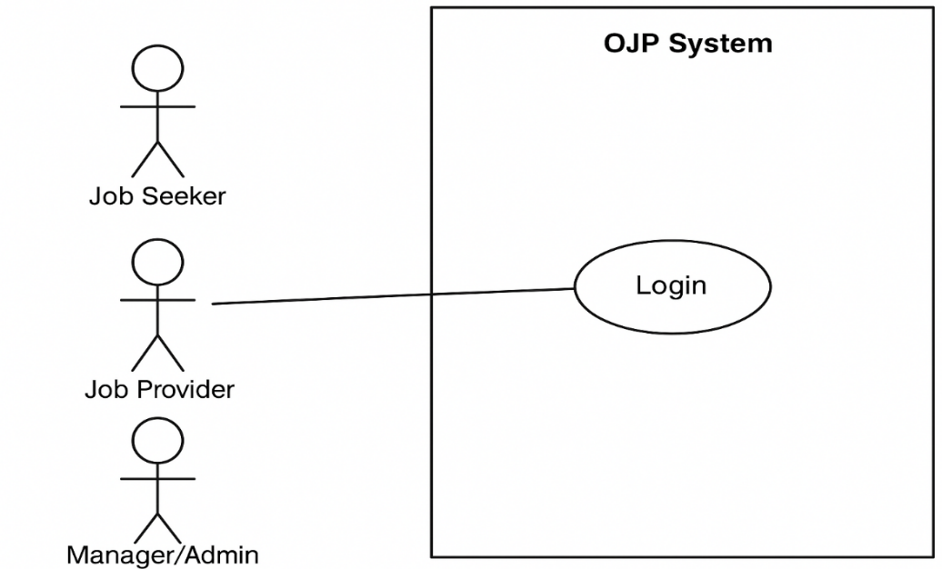

Figure 2.3.1 login use case diagram

Add product functional requirements

Functional Requirement 4 | Add product
Introduction | This feature allow Job Provider to add job.
Input | Click on the update button for modifying records.
Processing | The data source file is mapped along with templates to generate high volume dynamic documents
Output | Record updated successfully.
Error handling | Cannot be modify record check database connection.

Table 2.3.2 Add product functional requirements
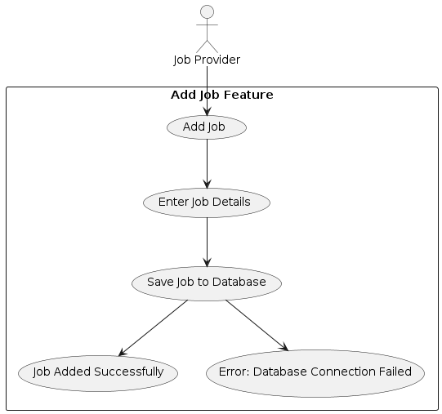

Figure 2.3.2 Add product use case diagram

Delete product functional requirements

Functional Requirement 5 | Delete product
Introduction | This feature allows Job Provider to delete existing record.
Input | Click on the delete button for modifying records.
Processing | The data source file is mapped along with templates to generate high volume dynamic documents
Output | Record updated/deleted successfully.
Error handling | Cannot be modify record check database connection.
Table 2.3.3 Delete product functional requirements
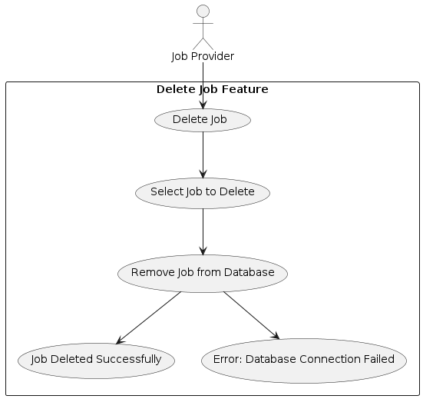

Figure 2.3.3 Delete product use case diagram

Manage users functional requirements

functional Requirement 6 | Mange users
Introduction | This feature allows Job Provider to manage users.
Input | Click on the manage users.
Processing | The data source file is mapped along with templates to generate high volume dynamic documents
Output | Record updated successfully.
Error handling | Cannot be modify record check database connection.
Table 2.3.4 Manage users functional requirements

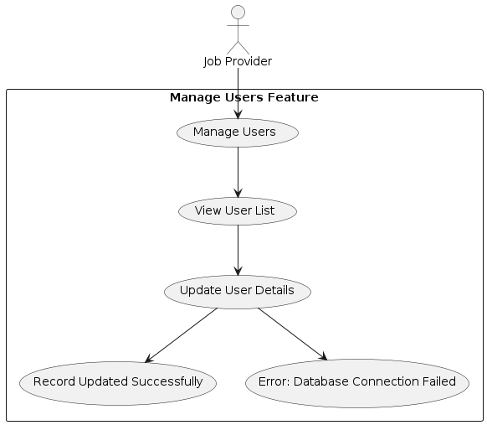

Figure 2.3.4 Manage users use case diagram

Logout functional requirements

Functional Requirement 8 | Logout
Introduction | This feature allows Job Provider, manager and Job Seeker to logout.
Input | Click on the logout.
Processing | The data source file is mapped along  with templates to generate high volume dynamic documents
Output | Logout successfully.
Error handling | Cannot logout.
Table 2.3.6 Logout functional requirements

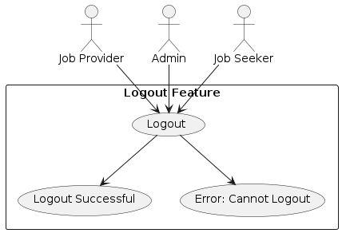
Figure 2.3.6 Logout use case diagram

Performance Requirements
The Online Job Portal System must perform efficiently to provide a smooth and fast user experience. Key performance considerations include:
- System Speed: Pages and job listings should load quickly to avoid delays for both job seekers and employers.
- Concurrent Users: The system must support multiple users accessing it simultaneously without performance degradation.
- Response Time: Actions such as job search, application submission, profile updates, and dashboard loading should have minimal response time.
- Data Accuracy: All operations must process correctly and consistently to maintain accurate records.
- User Satisfaction: Efficient performance will ensure users are satisfied and more likely to continue using the system.
- Record Management: Tracking, updating, and retrieving records should be straightforward and fast.

2.3 Logical Database Requirements
The database design of the system must follow logical structuring principles to ensure reliable storage and retrieval of information. The requirements include:
- Entity Representation: All real-world entities (Job Seekers, Employers, Jobs, Applications) must be represented in the database.
- Relationship Representation: Relationships between entities (e.g., Job Seeker applies to Job, Employer posts Job) must be clearly defined.
- Relation Merging: Related tables should be combined logically where necessary to avoid redundancy.
- Normalization: Database tables should be normalized to reduce data duplication and improve consistency.

2.4 Design Constraints

2.4.1 Standards Compliance
The Online Job Portal System is a web-based application developed using standard web technologies:
- Programming Language: PHP for server-side development.
- Database: MySQL for structured data storage.
- Frontend: HTML, CSS, JavaScript for responsive design and user interaction.
- Security Standards: Password hashing, input validation, and SQL injection protection must be implemented.
Other Constraints:
- The system must be compatible with modern web browsers.
- The design should follow a role-based access control model for security.

2.5 Organizing Specific Requirements
To ensure clarity and usability, system requirements are organized according to relevant categories. Different sections help in understanding system behavior from multiple perspectives.

2.5.1 System Mode
The system behaves differently based on the user role:
- Job Seeker Mode: Allows registration, profile management, job search, and application submission.
- Employer Mode: Provides job posting, candidate management, resume review, and shortlisting features.

2.5.2 User Class
Different users access different system functions:
- Job Seekers: Search jobs, apply, track applications.
- Employers: Post jobs, manage applications, view analytics.

2.5.3 Objects
Objects represent real-world entities in the system:
- Job: Attributes include title, description, category, required skills.
- User: Attributes include name, email, role, resume (for seekers).
- Application: Attributes include applicant details, status, and applied job.

2.5.4 Features
Features are external services desired by the users:
- Job search and filtering.
- Resume upload and application submission.
- Dashboard overview for personalized information.

2.5.5 Stimulus & Response
- Stimulus: User actions such as clicking “Apply,” posting a job, or updating a profile.
- Response: System must process the action and display confirmation, updated records, or error messages accordingly.

System Design and Architecture

Introduction to Use case Diagram
A Use Case Diagram is a type of UML diagram that visually represents the interactions between users (actors) and the system. It shows the different scenarios in which users perform actions and how the system responds.
The main components of a use case diagram include:
Actor
  - An actor is a person or another system that interacts with the Online Job Portal System.
  - Primary Actor: Performs actions, e.g., Job Seeker applying for a job or Employer posting a job.
  - Secondary Actor: Responds to the primary actor’s actions, e.g., the system verifying login credentials or sending notifications.
Use Case
  - Represented by oval shapes.
  - Each use case defines a specific action performed by an actor, such as:
    - Job Seeker: Register, Login, Search Jobs, Apply for Jobs.
    - Employer: Post Jobs, View Applications, Shortlist Candidates.
  - The number of use cases depends on system functionality.
System Boundary
  - Represented by a rectangle that encloses all use cases.
  - Actors are placed outside the system boundary.
  - Primary actors are usually on the left side; secondary actors are on the right side.
Relations
  - Association: A line connecting an actor to a use case they participate in.
  - Include Relation: Indicates that a use case always includes the behavior of another use case. For example, “Login Verification” may be included in “Apply for Job.”
  - Extend Relation: Indicates optional or conditional behavior, executed only when certain conditions are met. For example, “Invalid Login Message” extends “User Login” when credentials are incorrect.

Job Provider use case diagram

Figure 3.1 Job Provider use case diagram
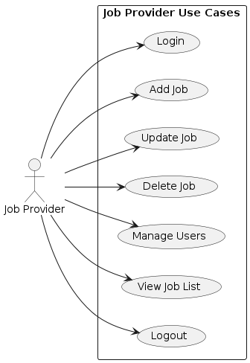

The Job Provider use case diagram represents all the main actions a Job Provider can perform in the Online Job Portal System. The Job Provider begins by logging into the system using valid credentials. After logging in, they can add new job posts by entering job details, update existing job posts when changes are needed, and delete any job that is no longer required. They can also manage users associated with the system, such as reviewing applicants or controlling related accounts. The Job Provider can view the complete list of all posted jobs to monitor their status and activity. Once all tasks are completed, the Job Provider can securely log out of the system. This diagram shows the complete interaction flow of the Job Provider with the system in a clear and organized way.

Job seeker use case Diagram

Figure 3.2 Job seeker use case diagram

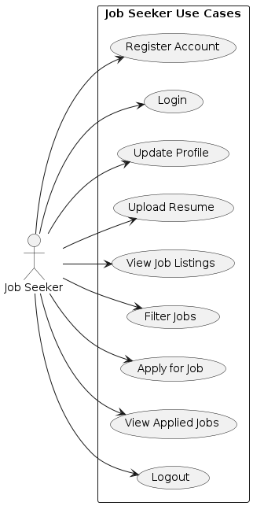

The Job Seeker use case diagram shows all the main actions a Job Seeker can perform in the Online Job Portal System. A Job Seeker starts by creating a new account through the registration process and then logs into the system using their credentials. After logging in, they can update their profile information and upload their resume to improve their chances of being selected. The Job Seeker can view all available job listings and use filters to search for jobs based on skills, category, or location. Once they find a suitable job, they can apply directly through the system and later view the list of all the jobs they have applied for. When finished, the Job Seeker can securely log out of the portal. This paragraph explains the complete interaction of a Job Seeker with the system as represented in the use case diagram.

Job Application Management Use Case Diagram

Figure 3.3 Job Application Management

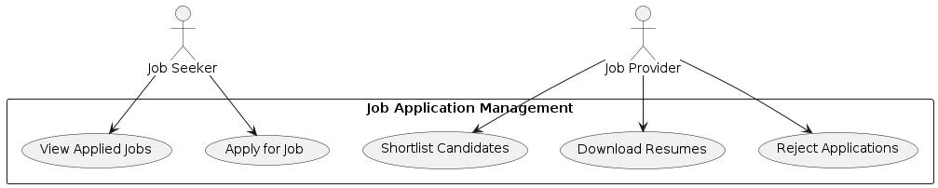

The Job Application Management use case diagram represents the workflow of how job applications are handled in the Online Job Portal System. The diagram involves two main actors: the Job Seeker and the Job Provider. Job Seekers can apply for jobs and view the list of jobs they have already applied to, allowing them to track their applications easily. On the other hand, Job Providers can manage the applications they receive by shortlisting suitable candidates, rejecting unsuitable ones, and downloading resumes for further evaluation. This use case diagram clearly illustrates the interaction between job seekers and providers, showing how the system supports the complete application process from submission to candidate selection.

Job Application Management Use Case Diagram

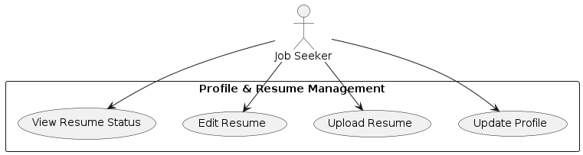

The Profile & Resume Management use case diagram illustrates how a Job Seeker interacts with the Online Job Portal to manage their personal and professional information. In this diagram, the Job Seeker can update their profile to keep personal details current, upload a new resume, edit an existing resume to improve or update it, and view the status of their uploaded resume. This diagram highlights the system’s functionality that allows job seekers to maintain an up-to-date profile and resume, which is essential for applying to relevant job opportunities efficiently.

Complete Use case Diagram of OJP
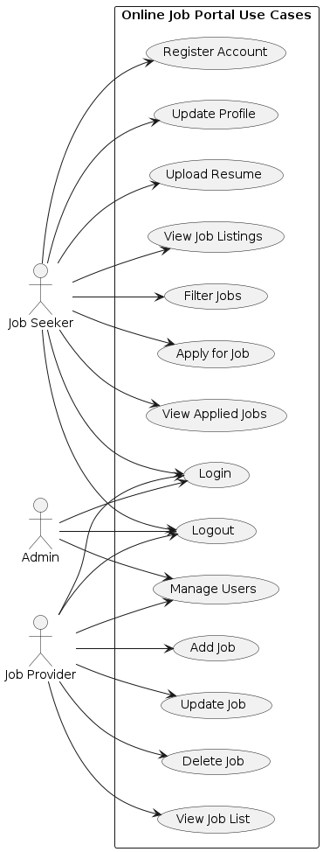

Figure 3.3Complete use case diagram

Data entities and their relationships
An ER (Entity-Relationship) Diagram is used to visually represent the entities in a system and the relationships between them. For the Online Job Portal System, the main entities and their relationships are described below:

Entities and Attributes
- Job Seeker
  - Attributes: SeekerID, Name, Email, Password, Resume, Skills, Contact Info
  - Description: Job Seekers register, maintain their profiles, search for jobs, and apply for available job postings.
- Employer
  - Attributes: EmployerID, Company Name, Email, Password, Company Profile
  - Description: Employers create company profiles, post jobs, update or remove job listings, and manage applications.
- Job
  - Attributes: JobID, Title, Description, Category, Required Skills, Posted Date, Status
  - Description: Represents a job vacancy posted by an Employer.
- Application
  - Attributes: ApplicationID, JobID, SeekerID, Application Date, Status
  - Description: Represents a Job Seeker’s application for a specific job.

Relationships
- Job Seeker – Application:
  - One-to-Many: A Job Seeker can submit multiple applications.
- Job – Application:
  - One-to-Many: Each Job can have multiple applications from different Job Seekers.
- Employer – Job:
  - One-to-Many: An Employer can post multiple jobs.

Representation in ER Diagram
- Entities: Rectangular shapes.
- Attributes: Oval shapes connected to their respective entities.
- Relationships: Lines connecting entities with cardinality (1:1, 1:N, N:M) indicated.

Non-Functional Requirements
Non-functional requirements define system characteristics that are not directly related to functional behavior, but are essential to ensure performance, reliability, security, and overall quality of the system.

3.4.1 Performance
- The system should perform efficiently 24/7 to provide uninterrupted service to both Job Seekers and Employers.
- Response times for key operations (job search, application submission, dashboard updates) should be minimal.

3.4.2 Reliability
- The system must consistently perform its intended functions under normal conditions.
- Data validation and verification must be implemented at every stage to ensure accurate and reliable operations.
- The system should handle multiple users simultaneously without errors or data loss.

3.4.3 Availability
- The system should be accessible to users at any time.
- Job Seekers and Employers must be able to access the system online whenever needed.

3.4.4 Security
- User authentication with ID and Password must be enforced for all users.
- Role-based access control:
  - Administrators have full authority to create, edit, and delete records.
  - Employers can manage only their own job postings and applications.
- Sensitive data (resumes, personal information) must be securely stored and protected against unauthorized access.
- Passwords must be hashed, and SQL injection prevention and input validation must be implemented.

3.4.5 Maintainability
- The system should be easy to maintain and update.
- Adding new features, fixing bugs, or modifying existing functionality should be straightforward.
- Only authorized administrators can perform maintenance tasks.

3.4.6 Portability
- The system should be transferable between different hardware and software environments with minimal effort.
- It should support deployment on different servers or hosting platforms without major modifications.

Portability

ID | Characteristic | H/M/L | 1 | 2 | 3 | 4 | 5 | 6 | 7 | 8 | 9 | 10 | 11 | 12
1 | Correctness
2 | Efficiency
3 | Flexibility
4 | Integrity/Security
5 | Interoperability
6 | Maintainability
7 | Portability
8 | Reliability
9 | Reusability
10 | Testability
11 | Usability
12 | Availability

3.5 Inverse Requirements (Constraints / Restrictions)
Inverse requirements define what the system should avoid during execution to maintain stability and performance. For the Online Job Portal System:
- The system should not consume excessive memory while running.
- The system should not crash even when multiple users access it simultaneously.
- Users should not be able to log in without valid credentials.
- Invalid actions (like applying for a job without logging in) should be prevented.
Note: These constraints ensure system stability, security, and a smooth user experience.

3.6 Logical Database Requirements
The database stores structured information for the Online Job Portal System. Logical requirements include:
User Account Information:
  - Stored for both Job Seekers and Employers.
  - Attributes include: UserID, Name, Email, Password, Role, Contact Info, Resume (for seekers), Company Profile (for employers).
  - Data must be organized to allow easy retrieval, search, and update.

Job Information:
  - Attributes: JobID, Title, Description, Category, Skills Required, EmployerID, Posted Date, Status.

Applications Information:
  - Attributes: ApplicationID, JobID, SeekerID, Application Date, Status.

Data Integrity:
  - All attributes must be validated before storage (e.g., unique UserID, correct email format).
  - Relationships between entities (Job Seeker → Application → Job → Employer) must be maintained logically.

3.7 Design Constraints
Design constraints are rules that limit system development or affect how the system operates. For the Online Job Portal System:
- Web-Based Application: The system is designed for modern web browsers with responsive layout.
- Programming Languages: PHP, HTML, CSS, JavaScript, and MySQL are used.
- Security Constraints:
  - Passwords are securely hashed in the database.
  - Role-based access is implemented to ensure proper permissions for Job Seekers, Employers, and Administrators.
  - No plaintext password storage or bypassing login is allowed.
- Maintainability Constraints:
  - The system should allow easy addition of new features or updates without major redesign.
- Performance Constraints:
  - The system must handle multiple users simultaneously and respond efficiently.

Analysis Model

4.1 Analysis Model Discussion
For the Online Job Portal (OJP) System, we use the Agile methodology to manage software development.
Why Agile for OJP:
- OJP is a web-based application that will be used continuously by Job Seekers and Employers.
- Agile allows iterative development and testing, so new features or changes can be added without stopping the system.
- Development and testing activities occur concurrently, unlike the traditional Waterfall model, which helps in faster delivery and better quality.
Key Principles Applied in OJP:
- Eliminating Waste: Avoid unnecessary features; focus on essential functionalities like job posting and applications.
- Amplifying Learning: Continuous feedback from users is used to improve the system.
- Deciding as Late as Possible: Features and enhancements can be added based on user needs during development.
- Delivering as Fast as Possible: Functional modules like login, job search, and application submission are released in iterations.
- Empowering the Team: Developers and testers collaborate to ensure smooth development.
- Building Integrity In: System is tested regularly to maintain reliability and correctness.
- Seeing the Whole: Focus on overall system performance and user satisfaction.
Using Agile, OJP can be continuously updated and improved without halting operations. This ensures that the system remains flexible, scalable, and responsive to user requirements.

4.2 Sequence Diagram
A Sequence Diagram is used to show the dynamic behavior of the system and the order of interactions between users and the system over time.
Key Components in OJP Sequence Diagrams:
- Actors: Job Seeker, Employer, and System.
- Messages:
  - Forward Message: Solid arrow indicating a request/action sent by the user.
  - Reply Message: Dotted arrow showing the system’s response.
- Lifeline: Vertical dotted line representing the existence of an object over time.
- Activation: Rectangular bar on the lifeline showing the duration an object is active while processing a request.
Usage in OJP:
- Job Seeker Login & Apply Sequence: Shows how a Job Seeker logs in, searches for jobs, and submits an application.
- Employer Login & Job Posting Sequence: Shows how an Employer logs in, posts a new job, and manages applications.
- System Notifications Sequence: Illustrates how the system sends confirmation messages or notifications after actions like application submission or job approval.
Sequence diagrams help visualize how users interact with the system step-by-step and ensure that all processes are properly defined and synchronized.

Add-User

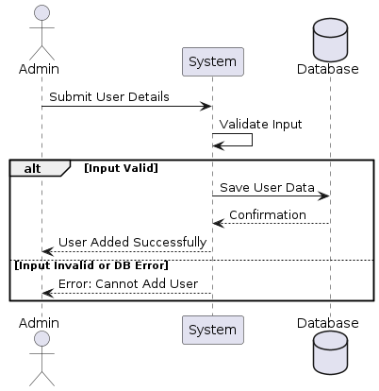

Figure 4.2.1 Add User sequence diagram

Update- User

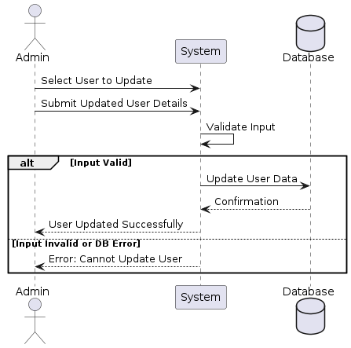

Figure 4.2.2 Update User diagram

Delete- User

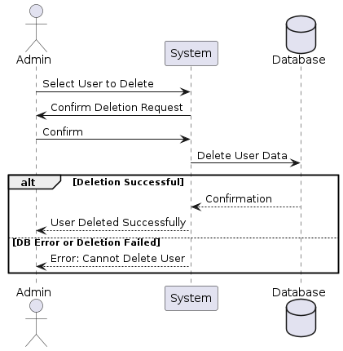

Complete OJB sequence diagram

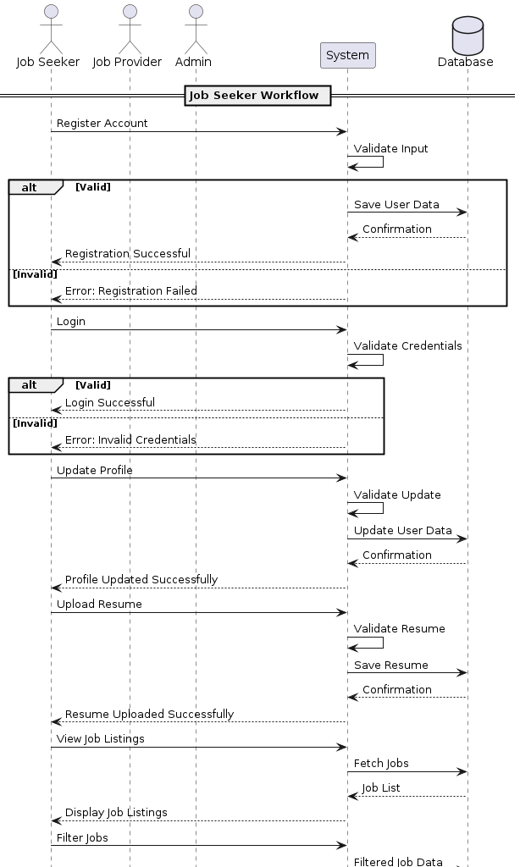

4.3 DFD Diagram
A Data Flow Diagram (DFD) illustrates how information moves through a system. It highlights data inputs, outputs, processes, and storage, showing how different entities interact with the system. DFDs are particularly useful for understanding complex processes in the Online Job Portal System (OJP).
Purpose of DFD in OJP:
- To visualize how Job Seekers, Employers, and the System interact.
- To identify inefficiencies or missing connections in the system workflow.
- To plan and design the system in a structured and efficient way.

DFD Levels in OJP

Context Diagram (Level 0 DFD)
- Provides a high-level overview of the system.
- Shows a single process node representing the entire Online Job Portal System.
- Illustrates connections between the system and external entities:
  - Job Seekers (inputs: login, job applications; outputs: application confirmation, notifications)
  - Employers (inputs: job postings, candidate selection; outputs: applicant resumes, notifications)
- Data stores and internal processes are not detailed at this level.

Level 1 DFD
- Breaks down the main process node into sub-processes for more detail.
- Key sub-processes in OJP include:
  - User Registration & Login: Handles account creation and authentication.
  - Job Management: Allows Employers to post, update, and remove job listings.
  - Job Search & Application: Enables Job Seekers to search for jobs, filter results, and submit applications.
  - Application Management: System records applications and updates their status (shortlisted, rejected, or accepted).
  - Notification System: Sends alerts to Job Seekers and Employers regarding application status, new job postings, or updates.
- Level 1 DFD also shows data stores:
  - User Database (stores Job Seeker and Employer accounts)
  - Job Database (stores all job listings)
  - Application Database (stores submitted applications and their status)

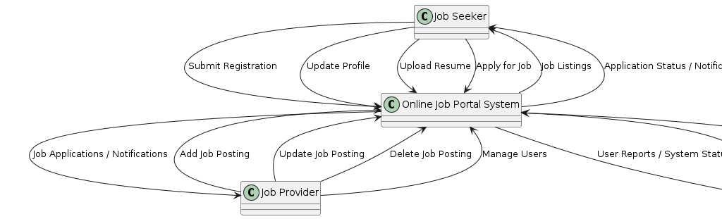
Figure 4.3 Context DFD

Detailed DFD
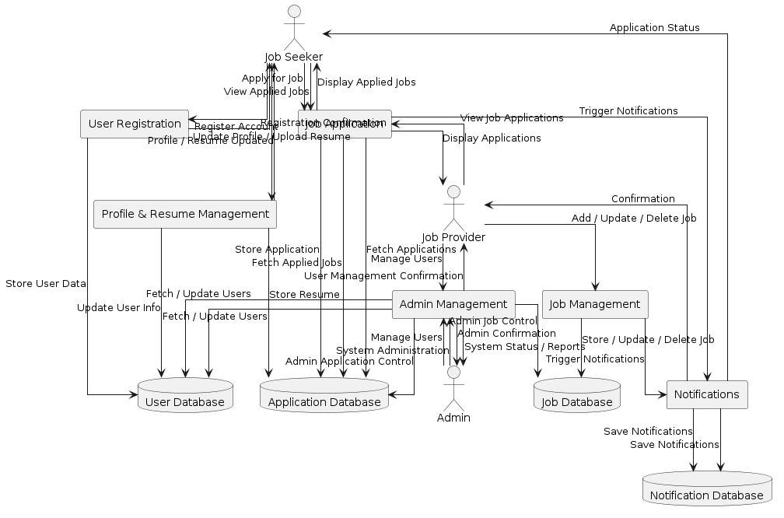

Figure 4.4 Detailed DFD
.

References
[1] R. Pressman and B. Maxim, Software Engineering: A Practitioner’s Approach, 8th ed. New York, NY, USA: McGraw-Hill, 2015.
[2] I. Sommerville, Software Engineering, 10th ed. Boston, MA, USA: Pearson, 2016.
[3] IEEE, “IEEE Std 830-1998 – IEEE Recommended Practice for Software Requirements Specifications,” IEEE, 1998.
[4] S. McConnell, Rapid Development: Taming Wild Software Schedules. Redmond, WA, USA: Microsoft Press, 1996.
[5] P. Kruchten, The Rational Unified Process: An Introduction, 3rd ed. Boston, MA, USA: Addison-Wesley, 2004.
[6] M. Fowler, UML Distilled: A Brief Guide to the Standard Object Modeling Language, 3rd ed. Boston, MA, USA: Addison-Wesley, 2003.
[7] A. Silberschatz, H. Korth, and S. Sudarshan, Database System Concepts, 7th ed. New York, NY, USA: McGraw-Hill, 2019.
[8] E. Gamma, R. Helm, R. Johnson, and J. Vlissides, Design Patterns: Elements of Reusable Object-Oriented Software. Boston, MA, USA: Addison-Wesley, 1994.
[9] L. Bass, P. Clements, and R. Kazman, Software Architecture in Practice, 3rd ed. Boston, MA, USA: Addison-Wesley, 2013.
[10] N. Fenton and J. Bieman, Software Metrics: A Rigorous and Practical Approach, 3rd ed. Boca Raton, FL, USA: CRC Press, 2014.
[11] PHP Documentation, “PHP Manual – PHP Language Reference,” 2023. [Online]. Available: https://www.php.net/docs
[12] MySQL Documentation, “MySQL 8.0 Reference Manual,” 2023. [Online]. Available: https://dev.mysql.com/doc
[13] M. K. Patel and P. B. Patel, “Online recruitment portal using PHP and MySQL,” Int. J. Adv. Res. Comput. Sci., vol. 9, no. 2, pp. 45–50, 2018.
[14] S. Ahmed and M. Khan, “A web-based job portal for efficient recruitment,” Int. J. Comput. Appl., vol. 162, no. 10, pp. 1–6, 2017.
[15] D. M. Fernández and B. Wagner, “Naming the pain in requirements engineering,” Empirical Software Engineering, vol. 22, no. 5, pp. 2298–2338, 2017.
[16] A. Cockburn, Writing Effective Use Cases. Boston, MA, USA: Addison-Wesley, 2001.
[17] B. Boehm, Software Engineering Economics. Upper Saddle River, NJ, USA: Prentice-Hall, 1981.
[18] D. L. Parnas and P. C. Clements, “A rational design process: How and why to fake it,” IEEE Trans. Softw. Eng., vol. 12, no. 2, pp. 251–257, Feb. 1986.
[19] S. Alavi and S. Leidner, “Research commentary: Technology-mediated learning,” MIS Quarterly, vol. 27, no. 4, pp. 675–694, 2003.
[20] R. B. Miller, “Response time in man–computer conversational transactions,” AFIPS Conf. Proc., vol. 33, pp. 267–277, 1968.

